RE

user

[Company name]  [Company address]

REPORT

Introduction

The website designed is about my personal portfolio career in a field of web development. Over the years my passion and skills on web development field have been increasing every time due to my curious creativity. My skills on web development have been growing steadily high since I was 12 years old when I first acquired my first computers. Over the years, have practiced different programming languages that solves web and desktop problems for my clients.

The practice of Computer coding has enabled me to reach on stages that I never expected to reach by discussing issues of technology globally. On this document, I shall showcase my true web design skills through communication of an actual website to my clients. The website will have for main pages that describes about portfolio, about me information and contact information for coding environment

**Home page**

This is the main page of the website. The page has images that are used to enhance visibility for the users of the website. On top of a page is a navigation bar that links to other pages on a website to make users access other contents inside the website. The navigation has black color to attract users on the web page whenever viewing. Below the navigation bar is an image for communication of information about my skills in a field of web development process

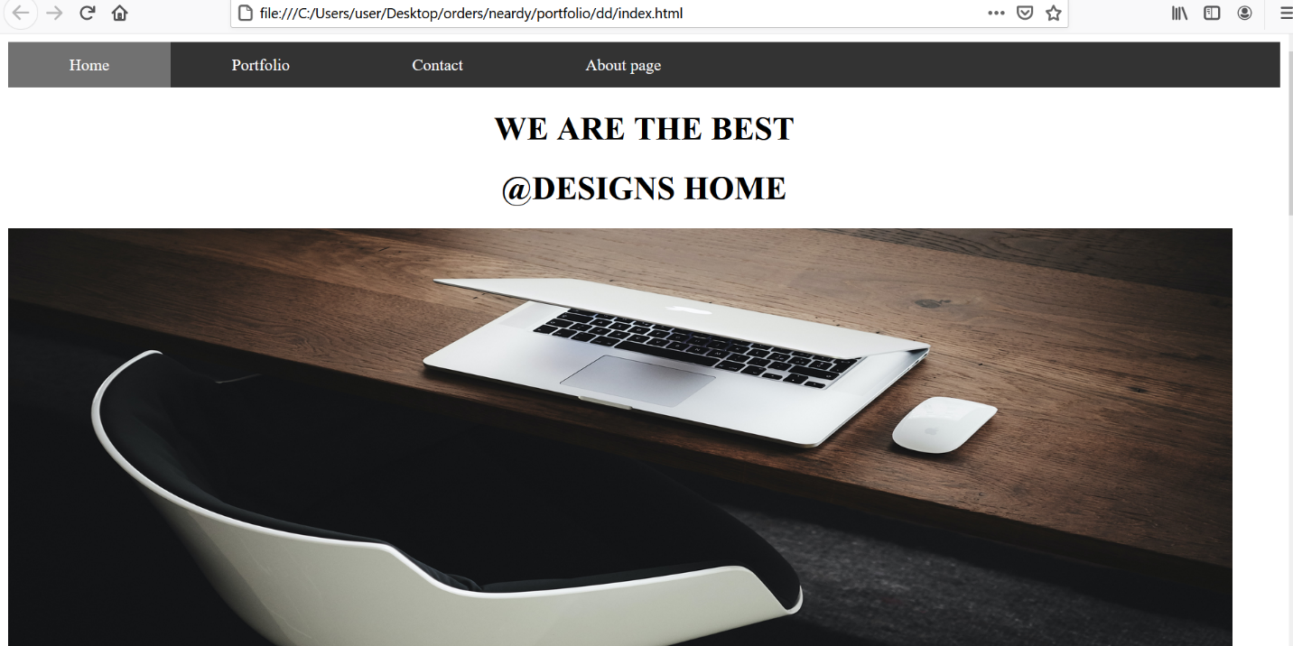

Fig: Showing home page of the website

After image, a paragraph of brief description that gives more information about my designs and passion I have towards web development process. CSS has been used in this section to position words on a best position for viewing. Lastly below the website is an image and footer. A footer gives positive feedback and has also been designed by CSS in order to have a background color. On other hand the image has been style to fit on the page

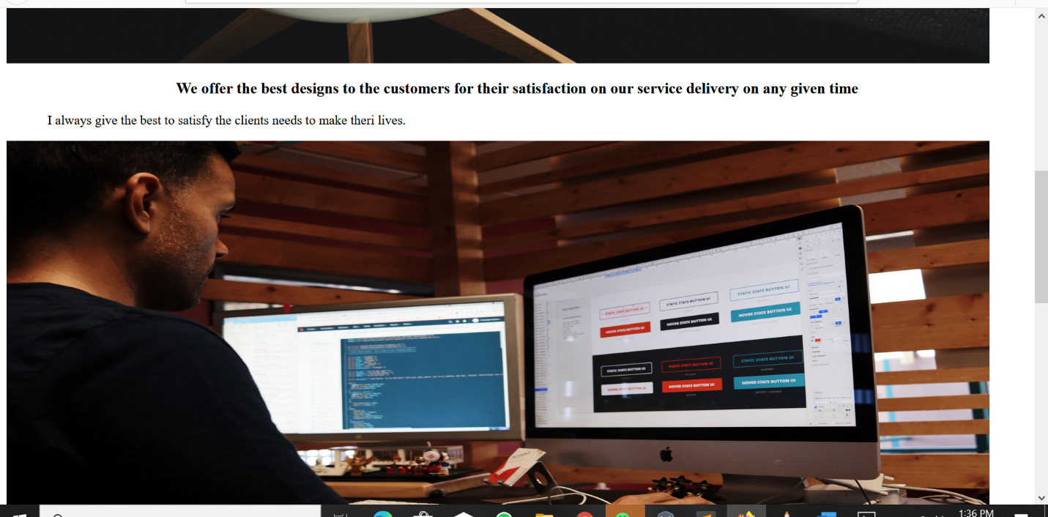

Fig: Showing home page of the website

Generally, the design of home page has got image and text to enhance proper communication to final users using the website.

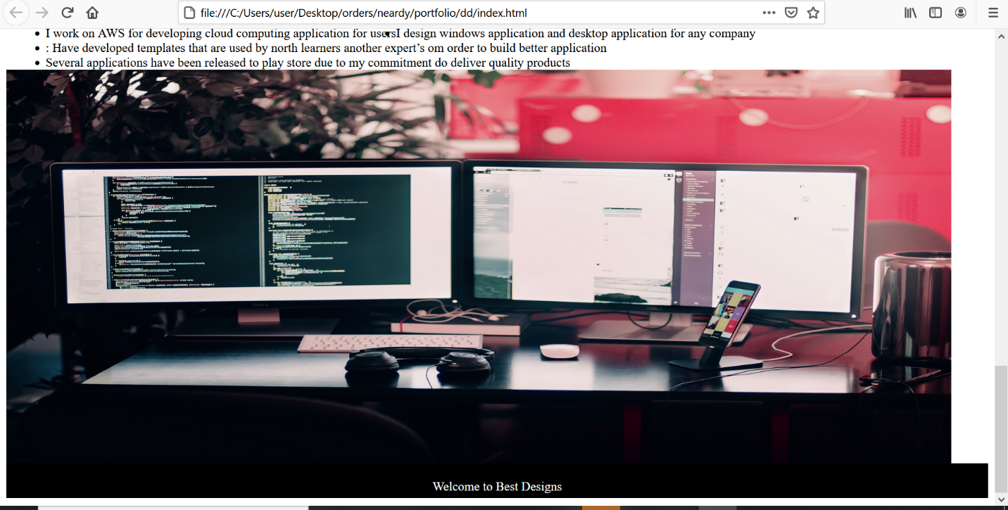

Fig: Showing home page design

**Portfolio**

The page gives my past projects and work experience on web design and development. The page start through use of the navigation bar that has links to other pages. Below the page are several section giving details about my experience and passion work have done in a field of web development. The following are some of the skills given on the page

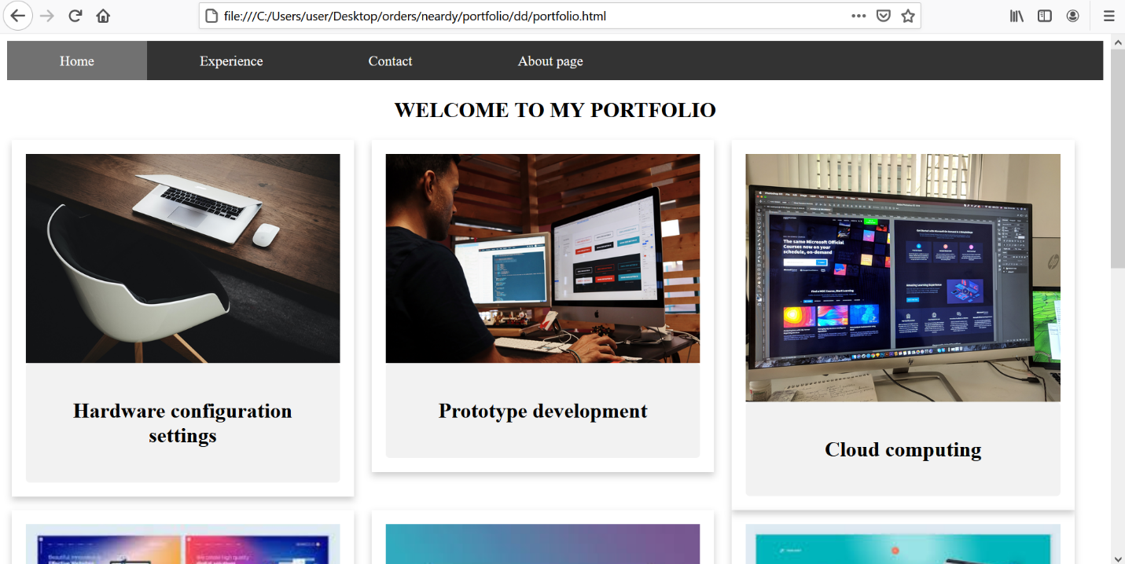

Hardware configure whereby I trouble shoot the machines to remove any problem that might arise due to software bugs

Prototype development: One of my best careers that involves development protypes that mimic the original application before the process of developer starts. Prototypes have developed include for school’s information system and banking information system

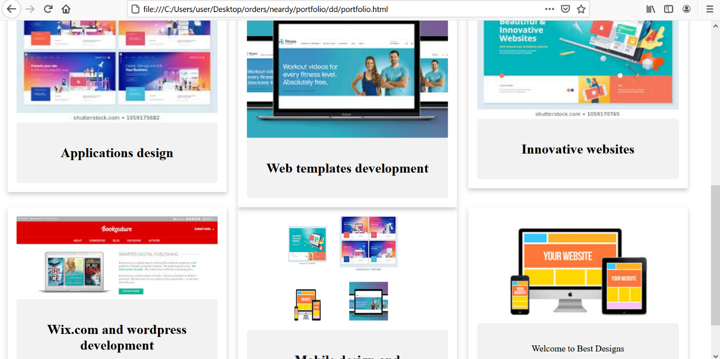

Fig: Showing portfolio page of the website

Cloud computing: I have worked on AWS for developing could application for of software’s such as SaaS. Some of the project have developed are on the GitHub section

Application design: I design laptops application and desktop application for any company. My design experience has enabled me to be invited on international conferences that involve designing process.

Web template development: Have developed templates that are used by most learners and other experts in order to build better application. These templates are found on my GitHub account.

Mobile designs and web designs: My knowledge and passion on web is always tremendous. Several applications have been released to play store due to my commitment to deliver quality products

Generally, the website page has been designed to for users to view the portfolio page on a better way. Have placed several images and divide the regions into rows. The raw in this case has the columns. The columns have also been added with images that are positioned inside the page. On the portal of the page is a footer which describes the information on the page.

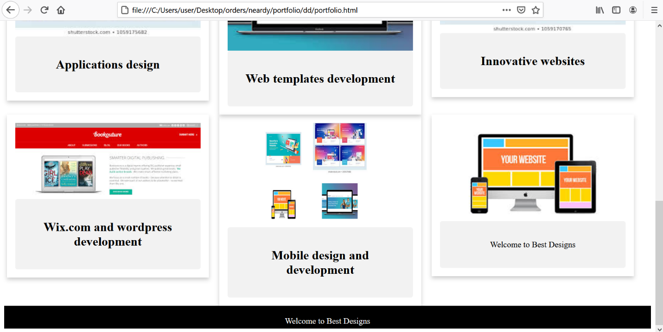

Fig: Showing portfolio page of the website

**Contact page**

This is another useful page on the website. The page is used to communicate information from the clients to my personal mail box. Like other pages, the page has a navigation bar that links to other pages. Below the navigation bar is a for that has various filed to carry information sent onto my side for communication. On bottom of the page is a footer that describes general information needed that has a black color like other parts

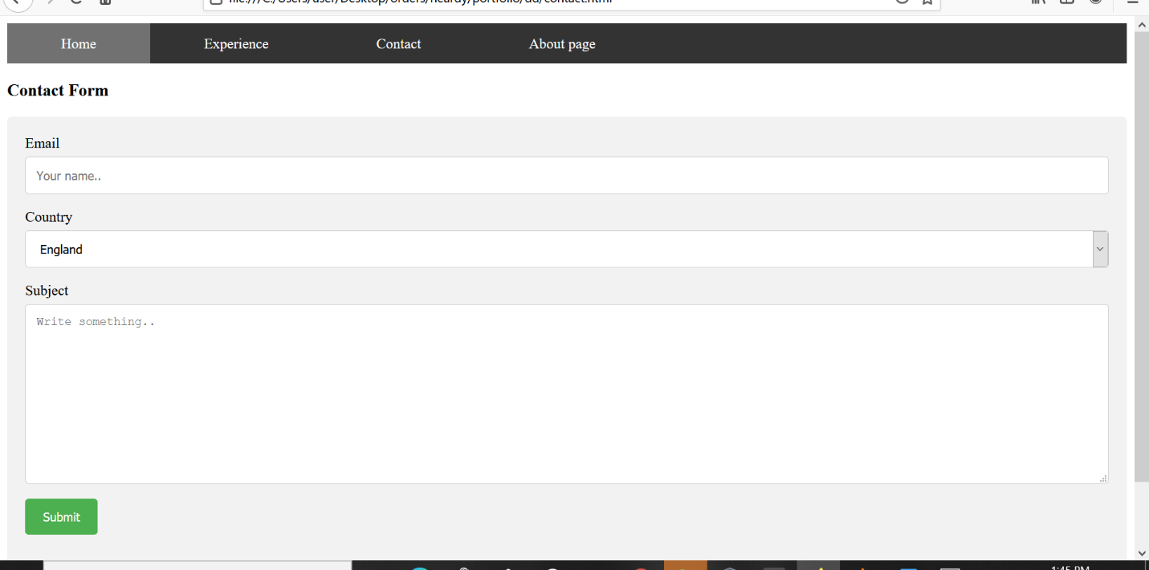

About page

This page gives more information about my personal life. On top of the page is a navigation bar that links to other pages on the website. After navigating bar, the page describes the personal hobbies I like and feature have designed. The page uses CSS to design the interface through use of colors for user to view the page easily and get attracted

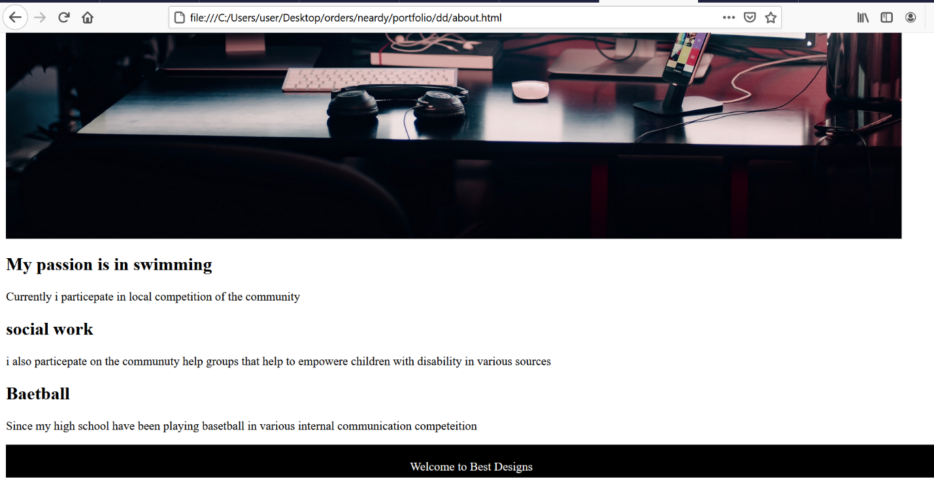

Conclusion

Through building this website, my skills of web development have greatly improved. My career in web design has changes in arranging select objects used on application. On other hand us of CSS language has enable me to arrange items on a web page in an order manner by avoiding disorganizing information on web page. The use of web images and linking one page to another is another skill that have improved. Through this application I plan to use it on an experience for interview in big web technologies in order to gain employment chances emerging. Finally, the application has shown me how technology evolves with time, Codes of web development are changing as ne methods of efficiency are used in a process of development.